EXTENDED ABSTRACT HEADLINE
(TIMES NEW ROMAN, 14 FONT SIZE, BOLD, ALL CAPS, CENTERED)

Author’s Name and Surname¹, Author’s Name and Surname² (11 font size)
^{1, 2} Authors’ Department, Institute, COUNTRY.
³ Author’s Department, Institute, COUNTRY.
(Corrseponding author E-mail: correspondingauthor@aaaa.bbb)
Please, indicate the corresponding author with an asterisk (*)

- INTRODUCTION (Title Times New Roman, 12 font size, bold)
This document explains and demonstrates how to prepare the ICHSU 2026 extended abstract. All abstracts should be written in English. Extended abstracts can contain figures, tables, formulations or images. Figures/photographs/tables can be placed in the extended abstract. Do not indent the text paragraphs. The extended abstract should be preferably written in MS Word format in single-spaced and 11 font size Times New Roman. Page margins are formed regarding the A4 page size and are 2.5 cm wide from the right, left, top and bottom. End of the lines should be aligned to the right. Extended abstracts should not exceed 1 page including the references. Authors are requested to submit extended abstracts in electronic form (MS-Word) to the Secretariat of ICHSU 2026 (ICHSU2026@163.com) by Apr. 15, 2026.

- EXPERIMENTAL
First degree headings (2.) should be written left aligned, all caps and bold. Equipment and method that have been used in the work must be stated clearly.

- RESULTS AND DISCUSSION
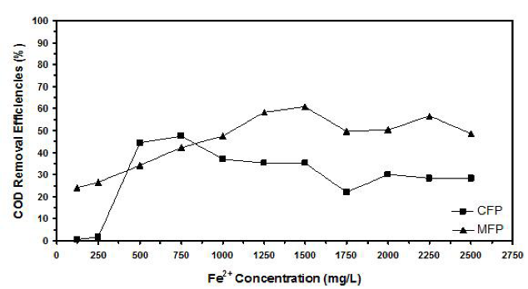
Results of the work and supporting figures, tables and images of the results should take part in the extended abstract.
Figure 1. Figure captions.
Figures and images should be numbered (Figure 1) and the figure caption should be placed under the figure or image. It is highly recommended that the figures be positioned on the right side of the text. The caption should be centered and written in 10 font size Times New Roman.

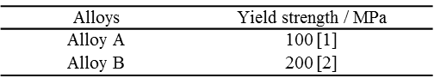
Tables should be numbered separately from figures (Table 1) and the table header should be placed at the top.
Table 1 Yield strengths of the alloys.
References (if any) of the tables, figures and images should be presented in the tables, figures and images.
Resources that have been presented inside [ ] in the text with numbers should be listed according to their order in the text.

REFERENCES
References that have been presented in the references list should be prepared in a format according to the reference style shown below (10 font size Times New Roman):

- S. Park, Sinclair, H.-S. Philip Wong, Z. Bao, Adv. Mater., 27 (2015), 2656.

